“On my honour, as student of University of Engineering and Technology, I have neither given nor received unauthorized assistance on this academic work.”





**CP102L Computer Programming Lab**

**Department of Computer System Engineering**

**University of Engineering and Technology Peshawar**

Submitted to: **Engr. Abdullah Hamid**

Submitted by: **Muhammad Saad**

Reg ID: **21PWCSE1997**

**DCSE, Batch 23, Section “B”**



Student Signature: ____________

**Lab No: 1**

* **Introduction to C++**

# Lab 1: Introduction to C++

## Objectives

* To be able to install and use Dev C++ IDE for compiling C++ programs
* To be familiar with syntax and structure of C++ programming

## Topics Discussed in Lab # 1

* Simple C++ Program and a Typical C++ Development Environment
* Test-Driving a C++
* Libraries
* Pre-processor Directives
* Variables and Data Types

## Lab Tasks:

1. Write a program to display your name on console.
2. Write a program to add two numbers (6+3=) and display its sum.
3. Write a program to multiply three numbers (5x5x5=) and display its product.
4. Write a program to find the mod of (5%2=) and (6%2=)
5. Write a program to calculate area of a circle having its radius (ask user to input radius).
6. Write a program to calculate area of an ellipse having its axes (ask user to input values of major, minor)

**Lab Tasks**

**Task No 1:**

Write a program to display your name on console.

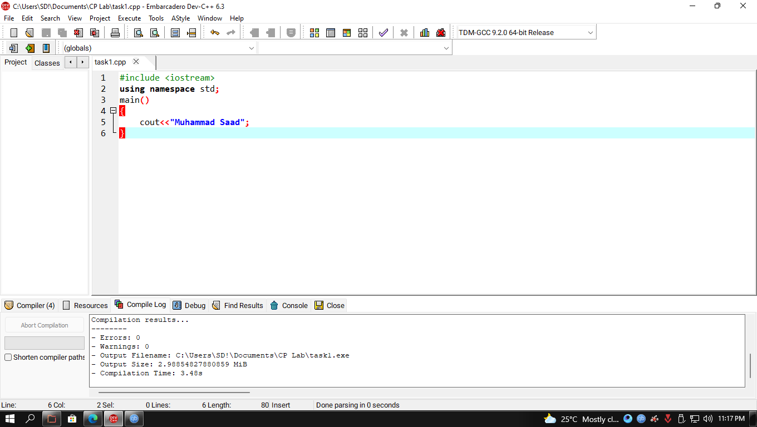

Code Screenshot

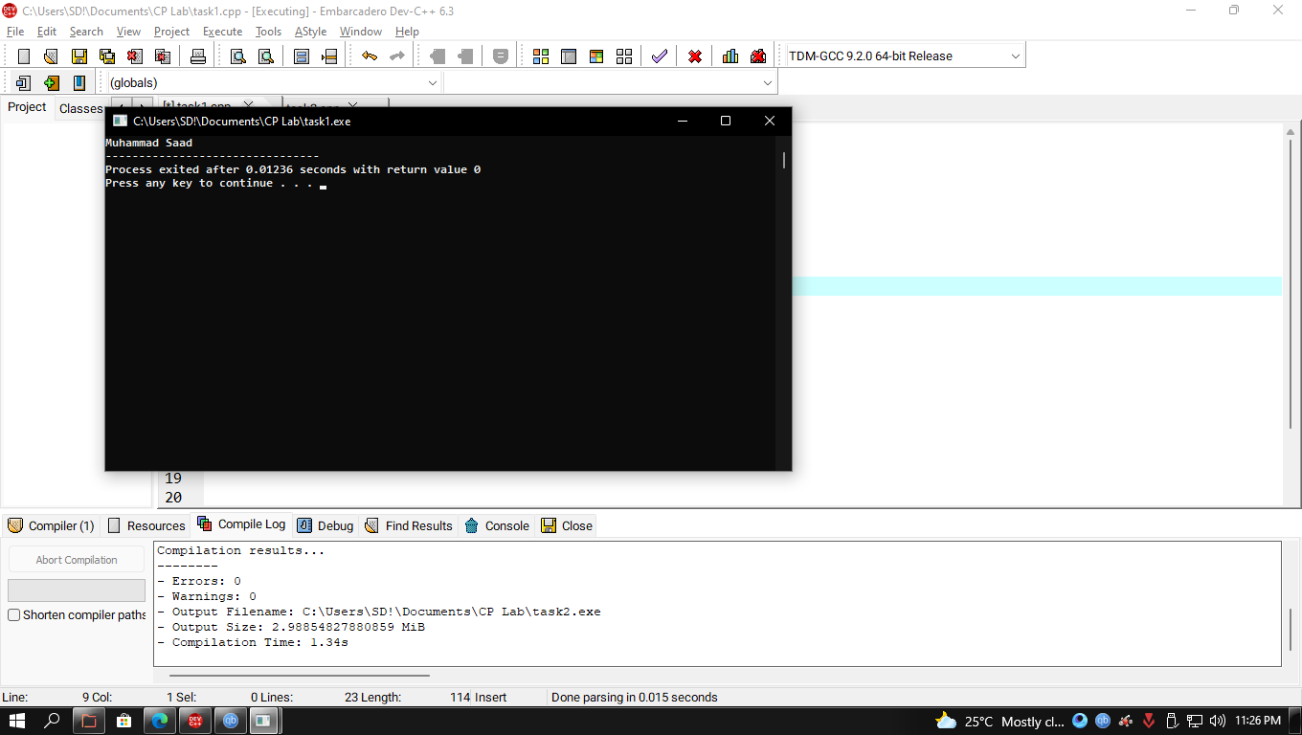Output Screenshot

**Task No 2:**

Write a program to add two numbers (6+3=) and display its sum.

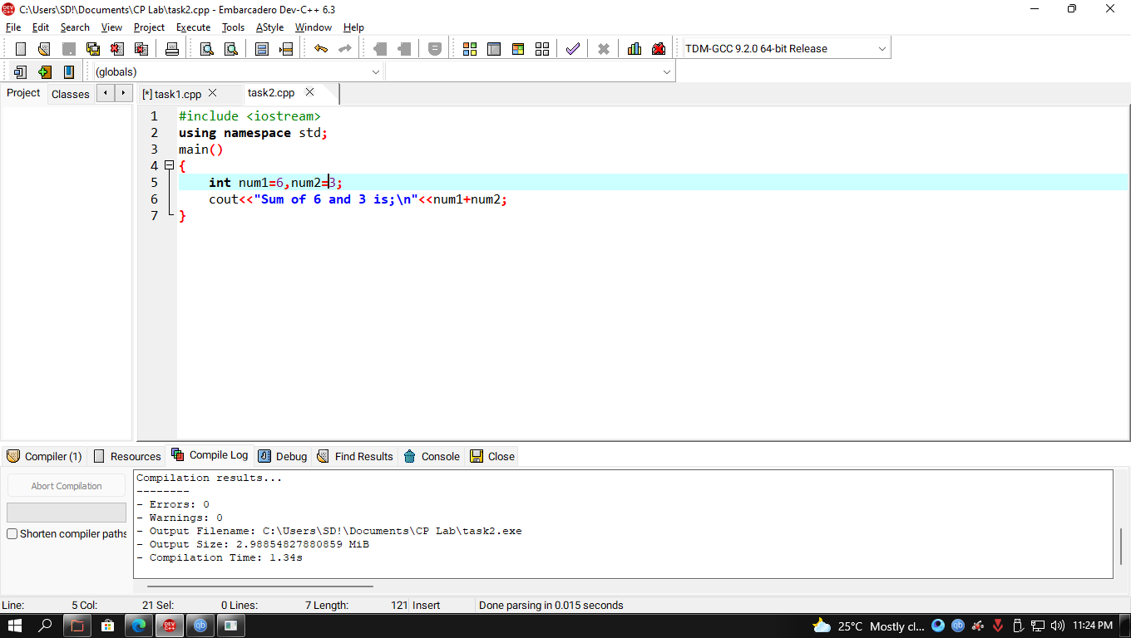Code Screenshot

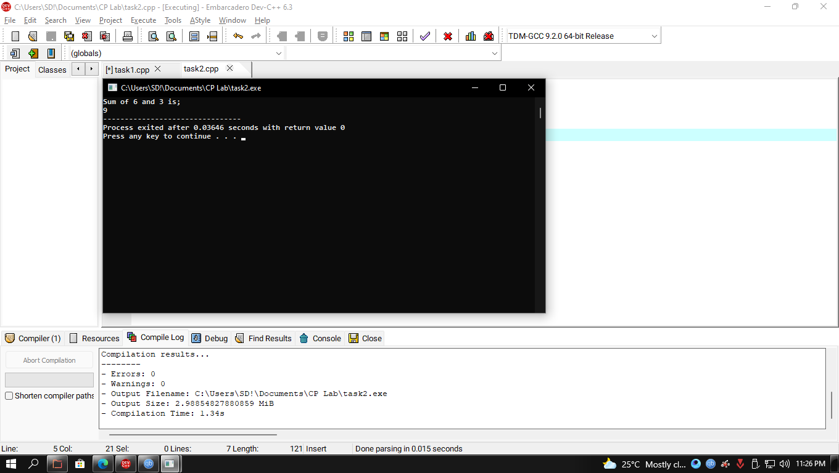Output Screenshot

**Task No 3:**

Write a program to multiply three numbers (5x5x5=) and display its product.

Code Screenshot

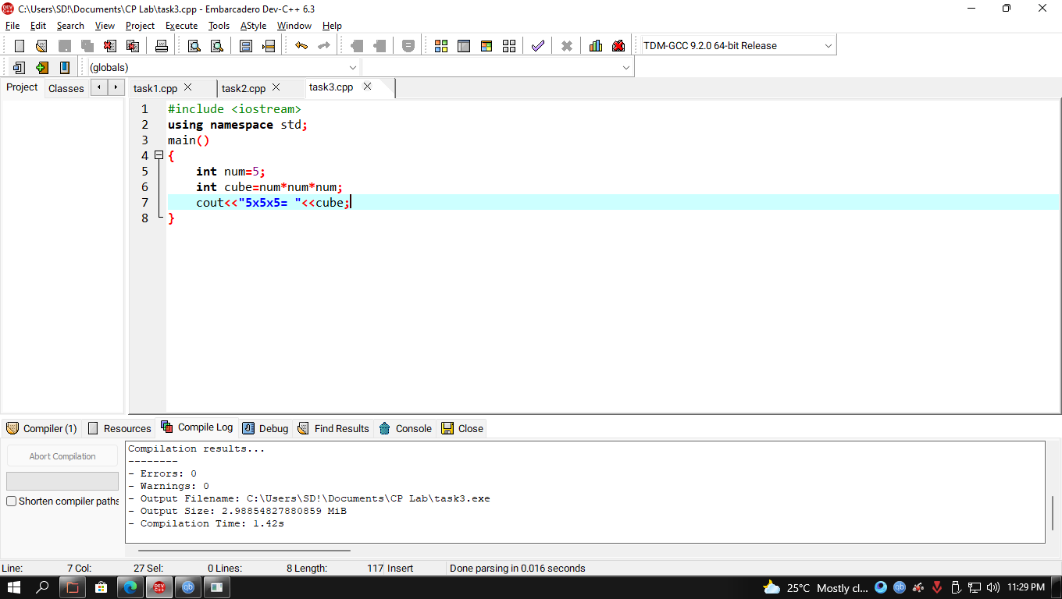

Output Screenshot

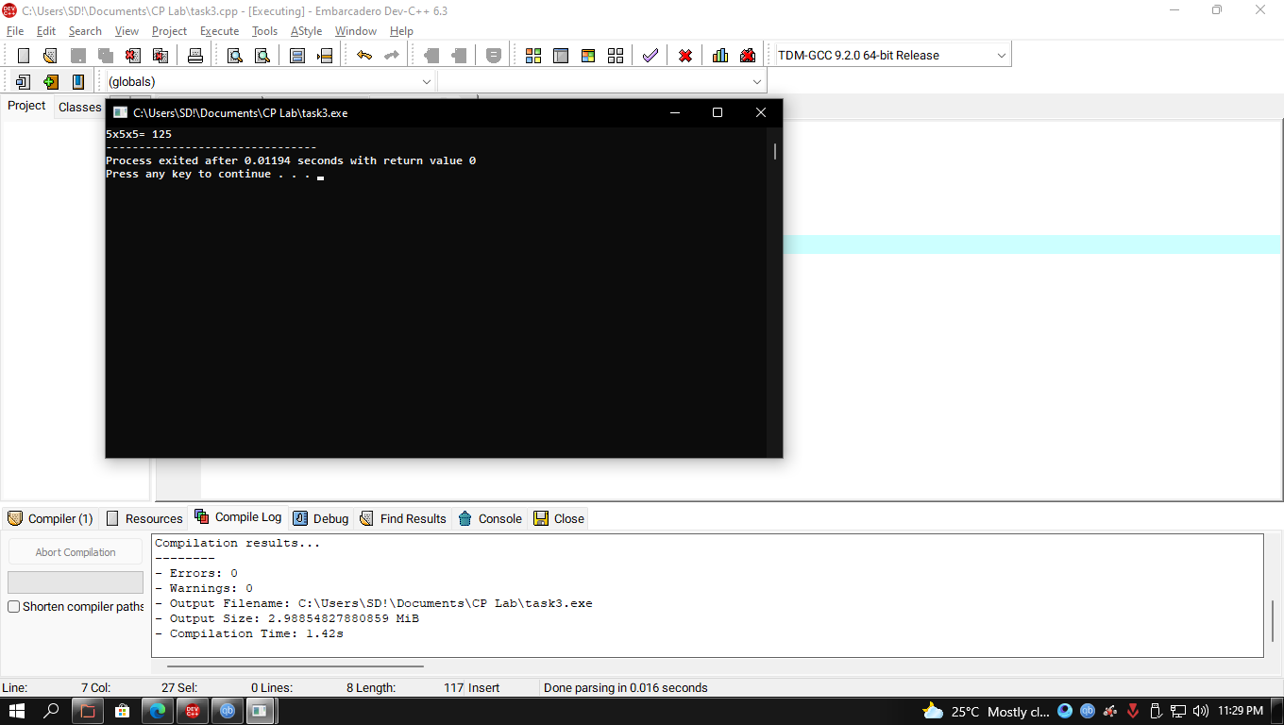

**Task No 4:**

Write a program to find the mod of (5%2=) and (6%2=).

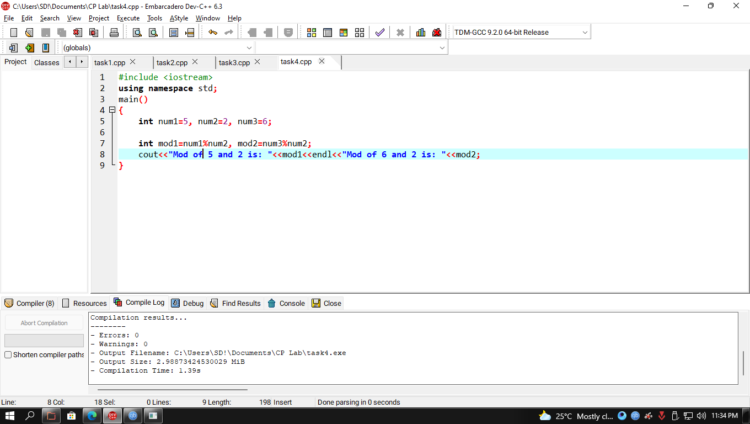Code Screenshot

Out Screenshot

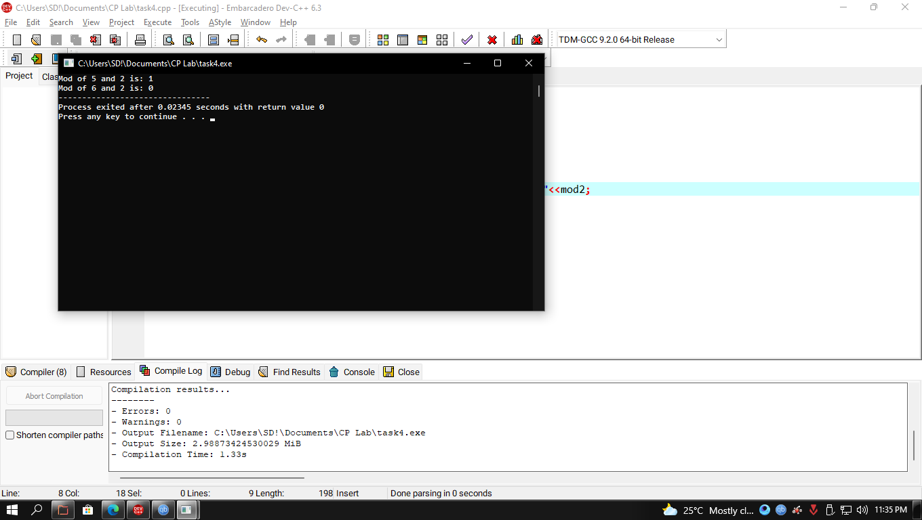

**Task No 5:**

Write a program to calculate area of a circle having its radius (ask user to input radius).

Code Screenshot

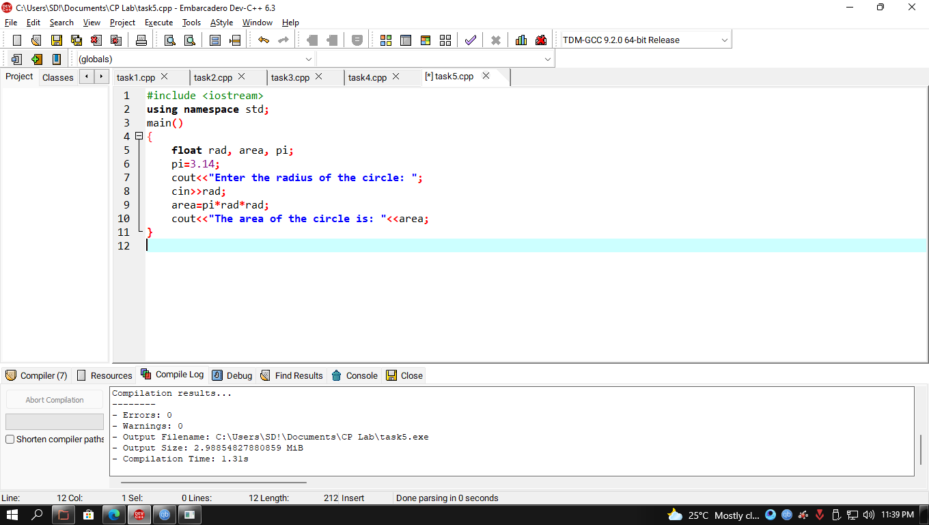

Output Screenshot

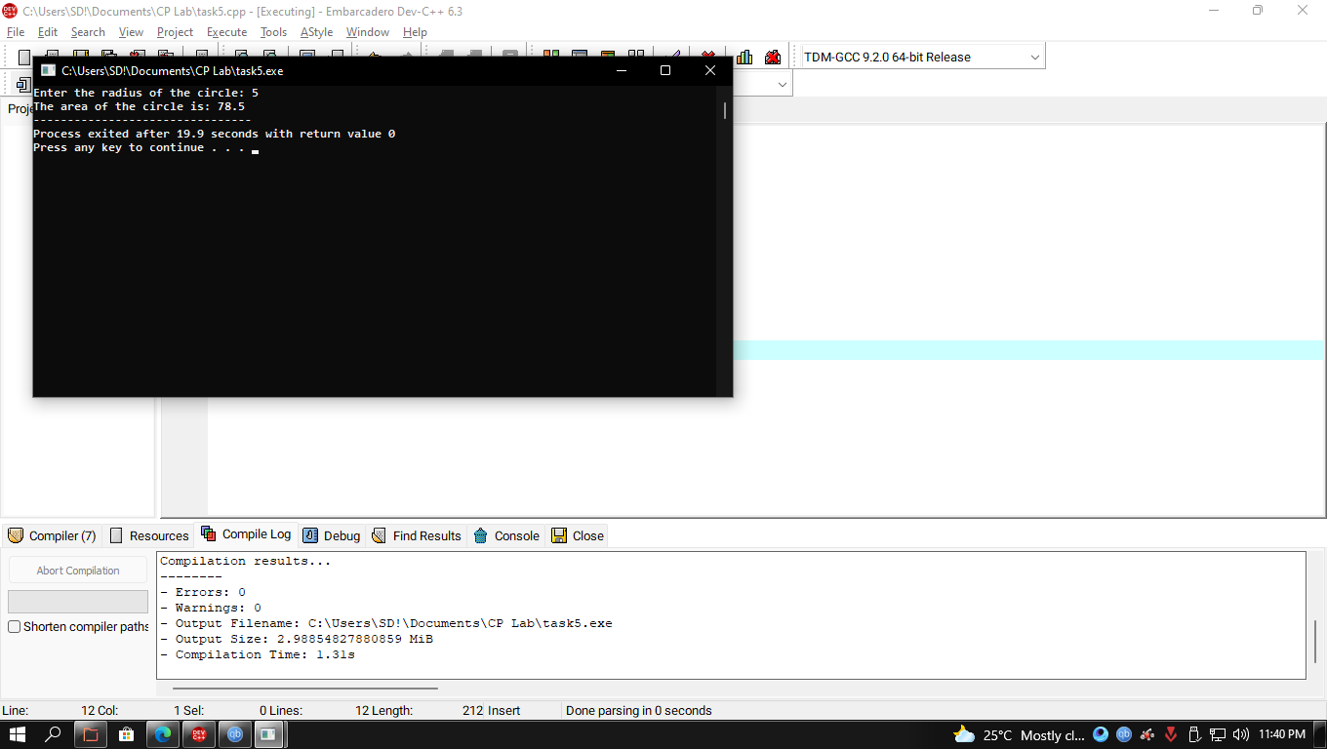

**Task No 6:**

Write a program to calculate area of an ellipse having its axes (ask user to input values of major, minor).

Code Screenshot

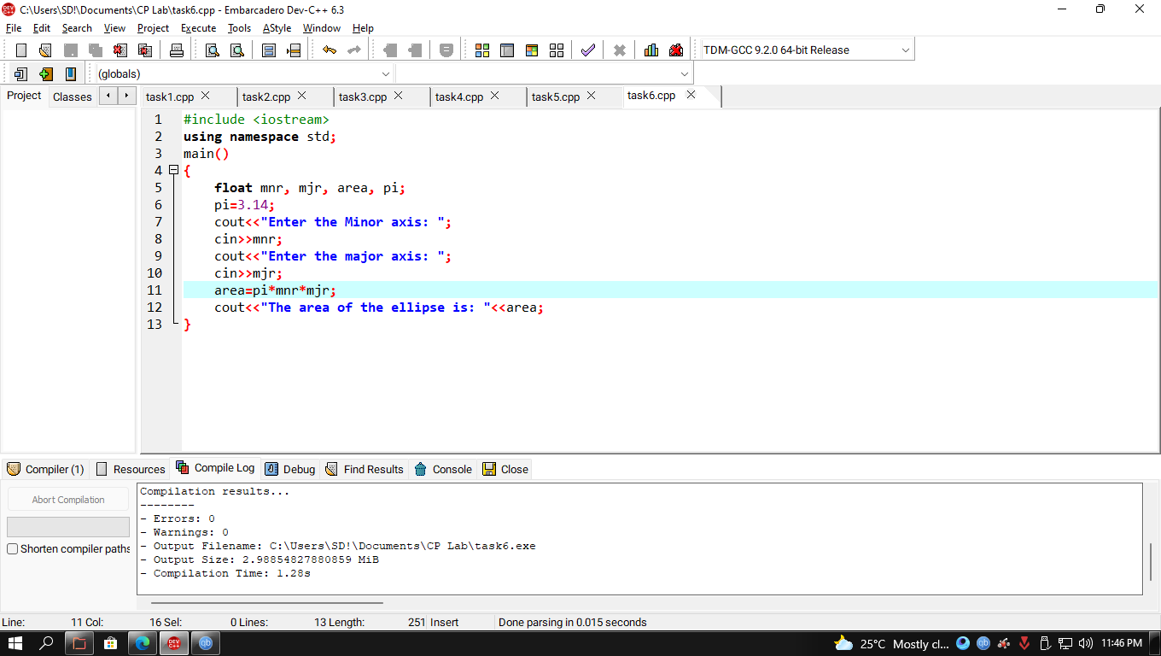

Output Screenshot

